Low Level Design (add Employee module)

Project Code | Team3
Project Name | Expense Management System

Prepared/Modified by | Role | Date of Preparation
Ayush Srivastava | Software Engineer | 05/12/2018
Reviewed by | Role | Date of Review
Tanmaya Acharya |  | 11/12/2018
Approved by | Role | Date of Approval
Circulation List | sumit.chuahan@capgemini.com  ayush.shrivastava@capgemini.com  ayush.a.choudhary@capgemini.com  rakesh.sangadikar@capgemini.com  yogesh.chacherkar@capgemini.com  shivani.jain@capgemini.com  deepesh.vishwakarma@capgemini.com  komal.b.pawar@capgemini.com | Version Number of the template:1.0
Version Number | 1.0

Table of Contents

1. Description Of The Unit 3
2. References 4
3. Dependencies / Assumptions 5
4. Class Diagrams 6
5. Sequence Diagrams 7
6. Design Components 8
7. Re-Usable Routines/Components 9
8. Messages 10
9. Configuration Files 11
10. Crud Matrix Table 12
11. Action Flow Matrix 14
13. Stored Procedures 15
REVISION HISTORY OF THE WORK PRODUCT 17

Description Of The Unit

In Add employee we can add employee details.
After entering all the employee details, the details are inserted into the database on sending data from postman.

In update employee we can update employee details.
After entering all the employee details, the details are updated into the database if data is present and it will update.
In Add employee we can add employee details.
After entering all the employee details, the details are inserted into the database on sending data from postman.
In delete employee we can delete employee details.
After entering all the employee id, the details are deleted from the database on sending id from postman.
In search employee we can search employee details.
After entering the employee id, we can search all employee details.

References

Reference | Description
Repository reference | https://github.com/yogeshchacherkar
Class Diagram | /Project Documents/Design Documents/HLD/Class Diagrams
URS | /Project Documents/Requirements/Case Study/Expense_management.doc
UTP | /Project Documents/Test Plan/UTP/Test Cases/AddEmployee /UTP_AddEmployeeCodeModule.xlsm

Dependencies / Assumptions

Assumptions:
The Employee details are stored in the database.

Class Diagrams

Class Diagram

Sequence Diagrams

Sequence Diagram
NA

Design Components

List Of UI Components
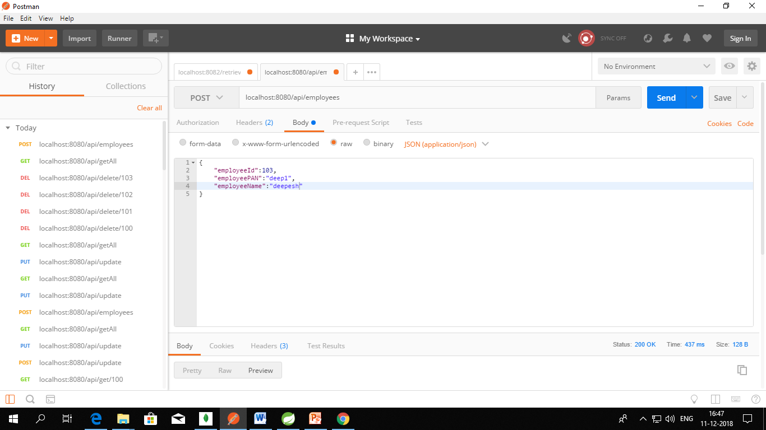

List Of Design Classes
Sr. No. | LLD Name | Class Name | Method Name | Method Description
1 | Add EmployeeCode Module | EmployeeBean | Appropriate getters and setters methods | Getters retrieve the property values and setters set the property values

Re-Usable Routines/Components

Re-Usable Routines/Components

- ECMException class
- Application yml file

Exception Messages

#. | Type | Message Text
M1 | Error | No value Present
M2 | Error | Enter valid Employee

Configuration Files

File Name | Path | Description
application.yml | /Development/Source | To configure database connection.

Crud Matrix Table

# | Table Name | Create | Read | Update | Delete
1. | Employee | Y | Y | Y | Y

Action Flow Matrix

Sr. No. | Action | Description | Process
1 | On entering details in json object. | All entities are entered in json object | User enter employee details in postman and it will insert into database.

Stored Procedures

# | Stored Procedure Name  (with Description) | Input/Out Parameters | Type | Size
1. | NA | NA | NA | NA
REVISION HISTORY OF THE WORK PRODUCT

# | Date | Version # | Section Changed | Details of changes made | Approved By
1 | 08/12/2018 | 1.0 | LLD prepared | N/A | Tanmay Acharya
2 | 11/12/2018 | 1.1 | Configuration files | Paths of the configuration files is updated. | Tanmay Acharya

